Movie Ticket Booking

By

Parimal Mehta
16BCE118
Parth Panchal
16BCE115



DEPARTMENT OF INFORMATION TECHNOLOGY
Ahmedabad 382481

Movie Ticket Booking

Mini Project – I

Submitted in partial fulfillment of the requirements

For the degree of

Bachelor of Technology in Computer Engineering

By

Parimal Mehta
16BCE118
Parth Panchal
16BCE118

Guided By
Prof. Jigna Patel
[DEPARTMENT OF COMPUTER ENGINEERING]

DEPARTMENT OF COMPUTER ENGINEERING
Ahmedabad 382481

CERTIFICATE

This is to certify that the project entitled “Movie Ticket Booking” submitted by Parimal Mehta(16BCE118) and Parth Panchal(16BCE115), towards the partial fulfillment of the requirements for the degree of Bachelor of Technology in Computer Engineering of Nirma University is the record of work carried out by them under my supervision and guidance. In my opinion, the submitted work has reached a level required for being accepted for examination.

Prof. Jigna Patel Dr. Sanjay Garg
Assistant Professor Dept. of Computer Engineering,
Department of Computer Engineering, Institute of Technology,
Institute of Technology, Nirma University,
Nirma University, Ahmedabad
Ahmedabad

ACKNOWLEDGEMENT

We would like to express our utmost gratitude to our mentor during this Mini-Project I, Prof. Jigna Patel as well as our Head of Department, Prof. Sanjay Garg who gave us the wonderful opportunity to research on the topic “Autonomous Navigations”. Working with our guide and researching this fascinating topic helped us improve in a lot of ways. It has helped us improve our people skills, learn how to do proper research, how to properly write a research paper and has given us a lot of valuable experience. The knowledge we gained from completing this project is just another bonus.

I would also like to thank our families and friends who helped us complete this project before the deadline. They would encourage us to do my very best and helped us out when we were stuck. Without them, this project would not have been as good as it is now.

ABSTRACT

Java is one of the most important programming languages today. The objective of Mini-Project 1 is to put our theoretical knowledge of Java to the test by making a Java application.
Through such a project, we can experience the development process with all the problems that come with it.
Here, we are going to use Java to make a Movie Ticket Booking System. We are using the NetBeans IDE for software development, Java Derby for Database Management, and Java Swing for the GUI.
We have implemented Authentication, Database Editing, and GUI for ticket booking.

Table of Contents
CERTIFICATE 3
ACKNOWLEDGEMENT 4
ABSTRACT 5
Introduction 7
Salient Features 7
Timeline 8
Progress 8
Diagrams 8
Flowchart 8
Use Case Diagram 9
Sequence Diagram 10
Class Diagram 10
Project Overview 11
Conclusion 11
Future Work 11
Appendix – A List of Useful Websites 11

CONTENTS
Certificate
Acknowledgement
Abstract
Table of Contents

Chapter 1 Introduction 1
1.1 General 1
1.2 2
1.2.1.1 3
1.4 Objective of study
1.5 Scope of Work

Chapter 2 Literature survey
  - General
  - Literature review (category wise)

Chapter 3
This chapter will contain the details of project work.

Chapter 4, 5, . . . . .
This chapter will contain the details of project work.

Chapter F Summary and Conclusion

Conclusion
(F stands for no. of final chapter)
References

Introduction

Our project is a Movie Ticket Booking System. The concept is similar to the popular website – BookMyShow. It allows us to book tickets for the latest movies. We have named it ‘KiTicket.

Salient Features

• A Home/Welcome page – Like a menu to access every option
• Log In
• Forgot Password – Implemented via OTP and email.

For Admin

• Adding a movie to a database
• View history of changes to movie roster
• View a summary of customer actions – Number of Views, Complaints, Visits, Bookings

For Customer

• Sign Up
• View log of previous bookings
• Movie Info page – Link a trailer, Description, Genre, Category, Language
• Booking a Movie – Selecting Date and Time
• Selecting Seats – Booked seats should be greyed out
• Display a confirmation page before payment
• Rate and Review a movie
• View reviews by fellow customers
• Promo Codes – For a loyal customer
• Food and Drinks
• Booking for R rated movies should be age verified.
• Payment

Timeline

- Basic Layout/UI
- Add functionality – First Draft
- Add extra features – Final Draft
- Host on Cloud – Optional

Progress

  - Log In UI
  - Sign Up UI
  - Change Password
  - OTP
  - Hashing
  - Admin Options – Add, Delete or Edit Database
  - View Movies
  - View Movie Info
  - Book Movie – Excluding actual seat selection
  - Confirmation screen

Diagrams

Before making the project, to plan out how we would develop our project, we made a few diagrams.

Flowchart

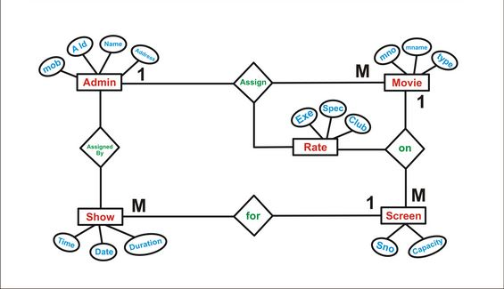

Use Case Diagram

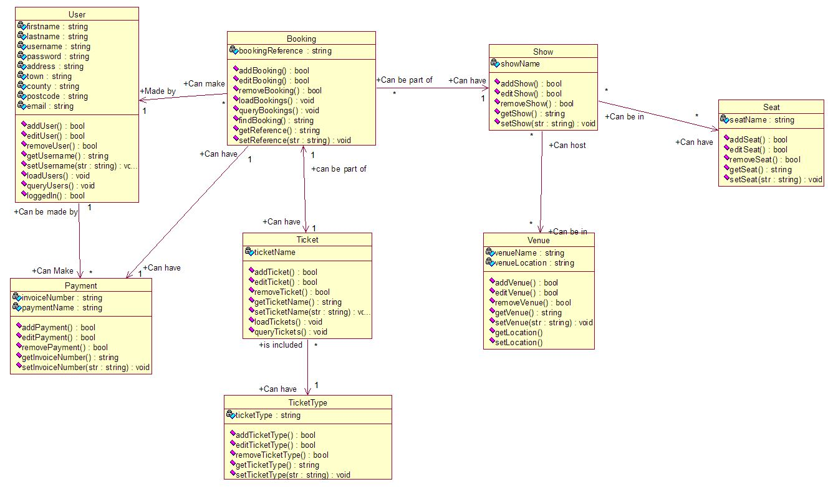

Sequence Diagram

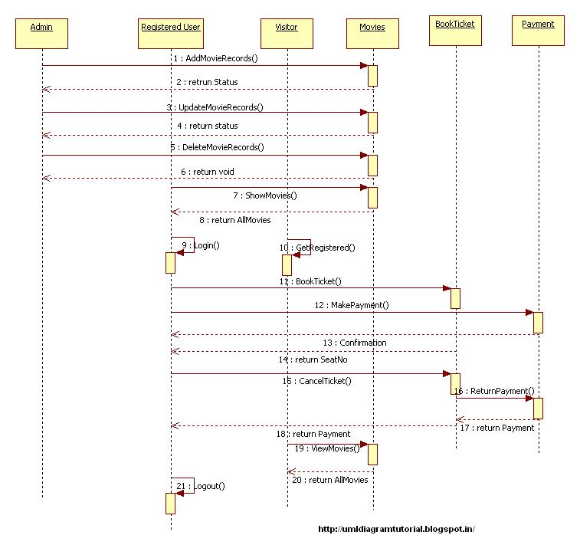

Class Diagram

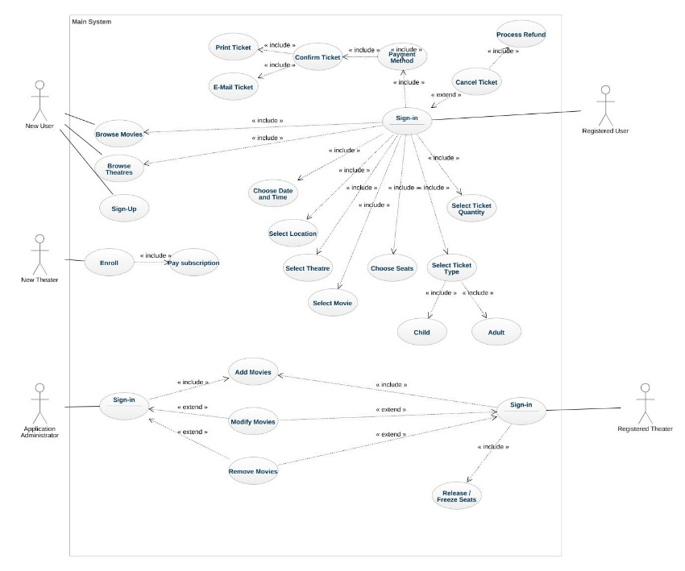

Project Overview

Now, we will be showing all the screens of the application and describing them.

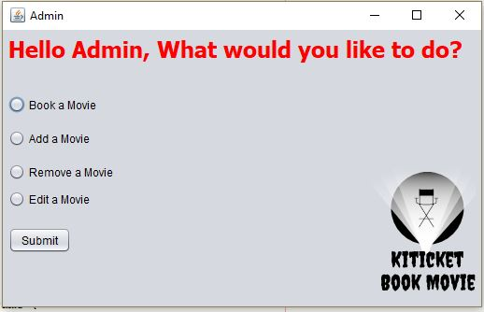
In this screen, we provide 4 options to admin only.
- To book a movie as a customer
- To add a new movie to the databases
- To remove a movie from the database
- To change movie details
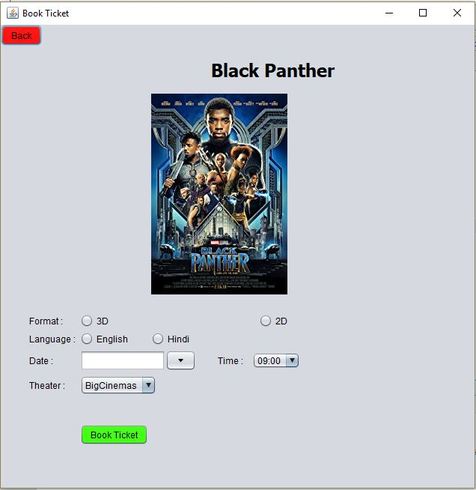

In this screen user can select
- Between 3D or 2D
- Language
- Date & Time
- Theater
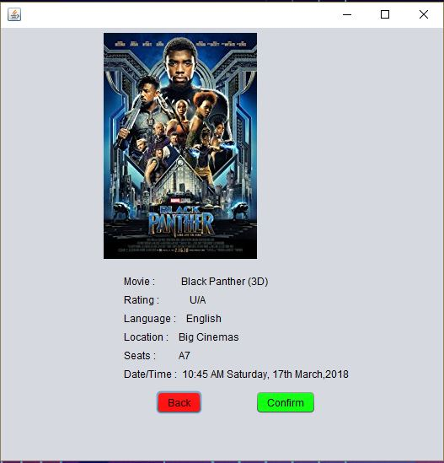

This is the confirmation screen,
- It shows all the details of user’s booked movie.
- By pressing Confirm button user will receive the email of the ticket details
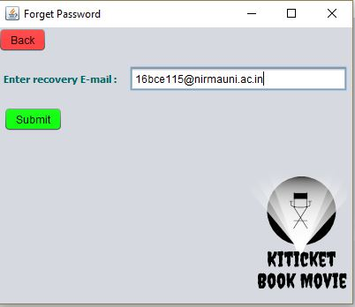

This is the recovery email screen, as a part of forget password process
- It will check whether the email is present in the database or not
- If email is verified then, it will send an otp

- Otherwise it will give invalid credentials error as shown in the picture below:

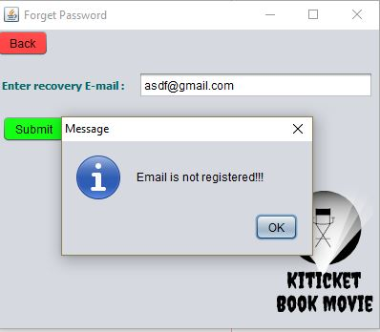

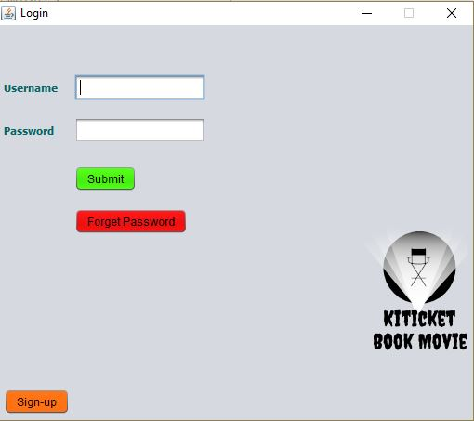

This is the Login screen.

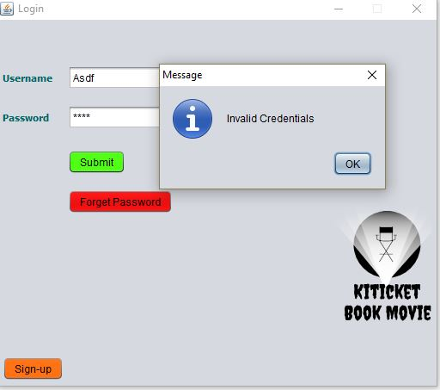

During authentication, if credentials are not matching, a warning will be given.
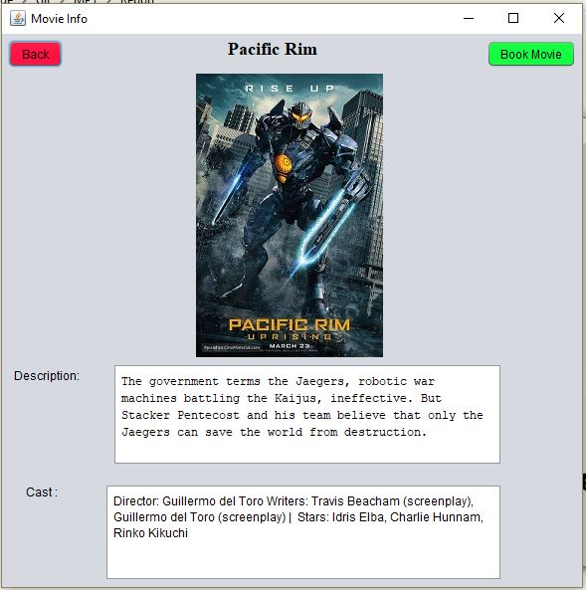

This describes the chosen movie.
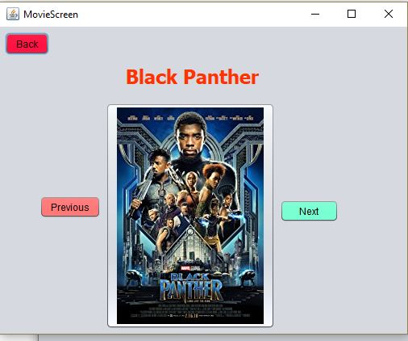

Here, we can view the various movies which can be booked.
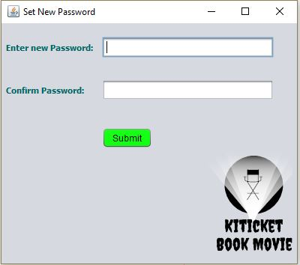

This is part of the Password Reset Process.
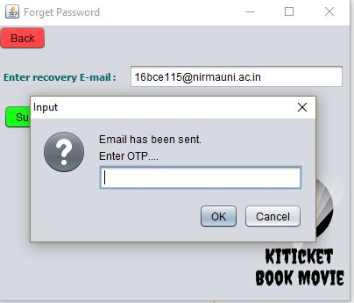

This is the part of the password reset process which checks if OTP is valid- the one sent to the email.

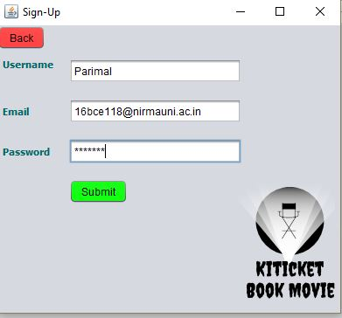

This is the Sign Up screen.
The password is hashed using MD5 before entering DB.

Conclusion

This project has helped us grow as developers. It has helped us experience the problems faced by programmers while developing an application. We have learned how to use JDBC, Swing and Netbeans. We have learned how to collaborate on GitHub and find answers and ask questions on StackOverFlow.

Future Work

As we continue to work on this project, we hope to implement a better seat selection mechanism, payment options, discounts and many more interesting features.

Appendix – A List of Useful Websites
- https://www.ntu.edu.sg/home/ehchua/programming/sql/MySQL_HowTo.html#intro
- http://www.homeandlearn.co.uk/java/connecting_to_a_database_table.html
- https://www.ntu.edu.sg/home/ehchua/programming/java/JDBC_Basic.html

